## **Blogger Template Installation Steps:-**

### **1. Backup & Uploading**

1. Unzip the Template.zip file.
2. On Blogger **Dashboard** Click **Template**.
3. Click on **Download Full Template** to keep your old template.
4. Click **Browse…** button. Find where the “theme.xml” file location.
5. Then Click **Upload**.
6. Edit mobile Preview. (follow images)

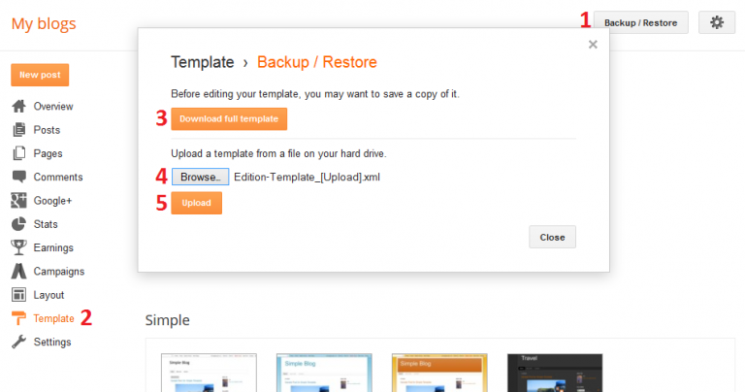

### **2. Blog Setting**

After installing the theme, there are minimum settings to make all widgets work fine in this template.

1. On Blogger **Dashboard** Click **Settings**.
2. Click **Other**.
3. In **Site Feed** > **Allow Blog Feed** Choose **Full**.
4. Then Click **Save settings**.

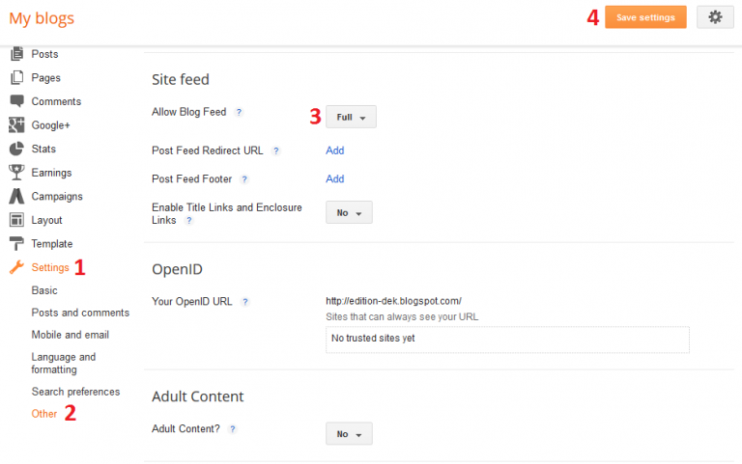

### **3. Logo Setup**

1. In your [dashboard](https://blogger.com/home) select “Layout”.

2. Upload Your Logo Header: In You Blog (Header), Click on “Edit” and applicate all settings below :

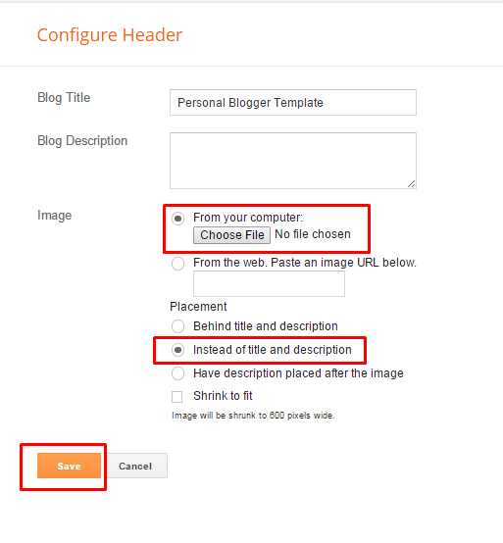

### **4. Navigation Menu**

#### **4.1 Top Menu Setup**

**Screenshot_1**

* On Blogger **Dashboard** Click **Layout**.
* Click **Edit** on **Top Navigation** Widget.
* Change it according to your needs. Add name of the **link Name** and **link URL** then click **add Link**
* Click **Save**.
* Change the location of menu item using the arrow down and arrow up Icon

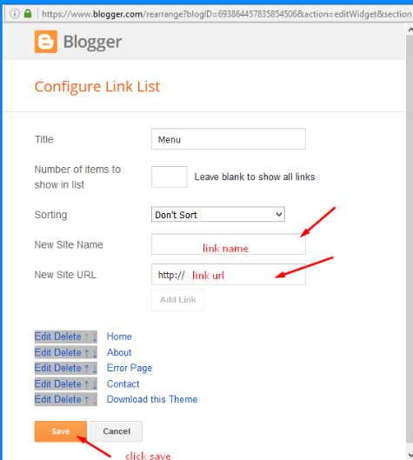

#### **4.2 Main Menu/DropDown**



* On Blogger **Dashboard** Click **Layout**.
* Click **Edit** on **Main Menu** Widget.
* Change it according to your needs. Add name of the **link Name** and **link URL** then click **add Link**
* Click **Save**.
* To Add submenu Item. You have to add “\_”(underscore without quotes) before Menu item Link (**example**: **\_Left Sidebar**)
* Change the location of menu item using the arrow down and arrow up Icon
* For More Information- Watch Video Below



### **5. Social Top / Social Footer**

Access your blog **Layout >** click **Edit** link on **Social Top** **/ Follow Us (Sidebar)** / **Social Footer** widget.

**Social Names:**  *facebook, twitter, gplus, bloglovin, rss, youtube, skype, stumbleupon, tumblr, vine, stack-overflow, linkedin, dribbble, soundcloud, behance, digg, instagram, pinterest, delicious, codepen*

*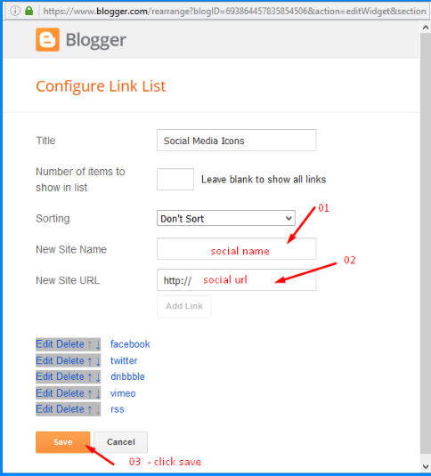*

**Example:**

For Example if you have to add “facebook” icon then just add facebook in name of New site name section and below add url of that particular site.

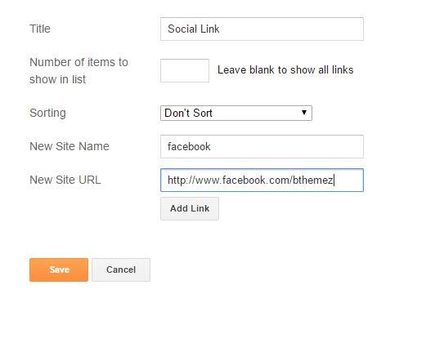

### **6. Featured Posts**

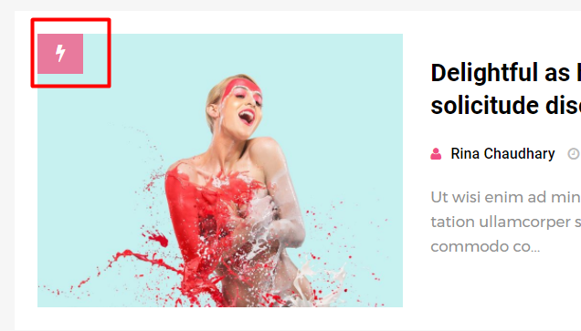

When you are writing a post add “featured” word as a label in your post. In which post you add these label that post automatically add a Badge on the corner of the post.

**Make sure you write “featured” not “Featured” it is case sensitive and the same for the popular**

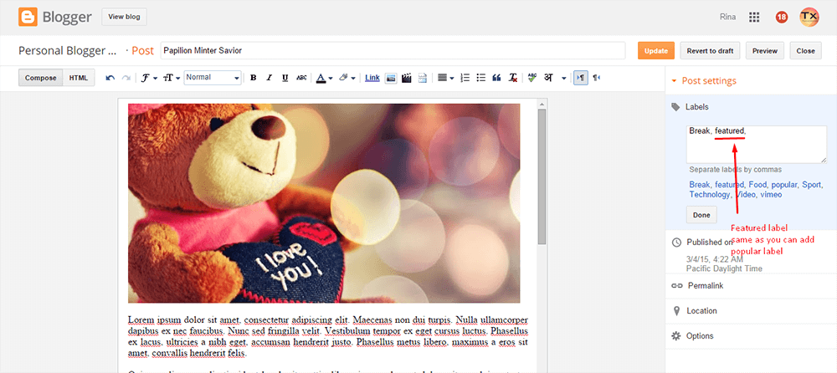

### **7. Widgets**

Access your blog **Layout >** click **Add a Gadget** > **HTML/JavaScript** on **Sidebar or Footer** section, you must place the following names highlighted in blue below.

Recent Posts: **recentposts**

Random Posts: **randomposts**

After add, click save.

### **8. Theme option:**

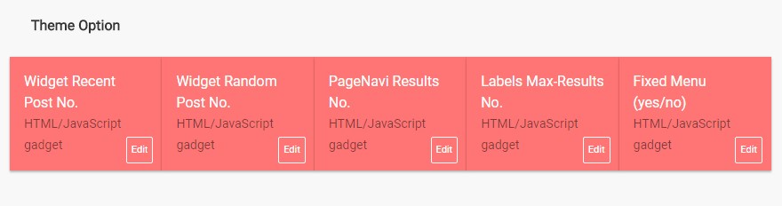

* **Widget Recent Post No.**

Add your desired number to change the count of recent posts widget.

* **Widget Random Post No.**

Add your desired number to change the count of recent posts widget.

* **PageNavi Results No.**

Add your desired number to change the count of main posts.

* **Label Max-Results Results No.**

Add your desired number to change the count of posts on label pages.

### **9.Comments System**

Access your blog **Layout >** click **Edit** linkon **Comments system** widget.

You can trigger the provisions below.

Only Blogger add: **[blogger]** and click save!

Only Disqus add: **[disqus]** and click save!

Only Facebook add: **[facebook]** and click save!

More:**[facebook][disqusss]**

**[blogger][facebook]**

**[facebook][blogger]**

**[disqus][facebook][blogger]**

**[blogger][disqus][facebook]**

**[disqus][blogger][facebook]**

**NOTE:** The display of all is only available in that provision.

**NOTE 02:** To view the system Disqus comments, you need to follow the steps below.

### **Disqus Shortname**

Access your blog **Layout >** click **Edit** linkon **Disqus Shortname** widget.

* What you have to do is just add the shortname

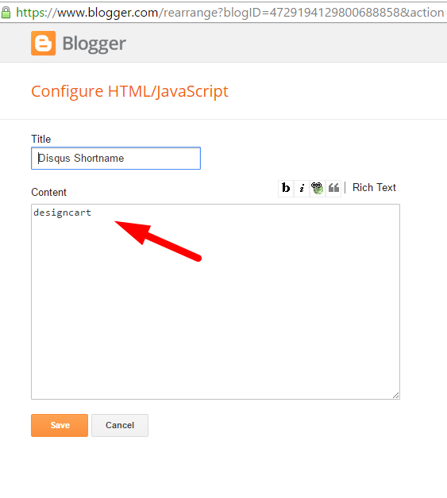

### **10. Page Layout / No Sidebar / Left Sidebar**

To add these options just add the codes below in the composition of the post!

**Codes: [no-sidebar]**

**[left-sidebar]**

### **Image Example:**

**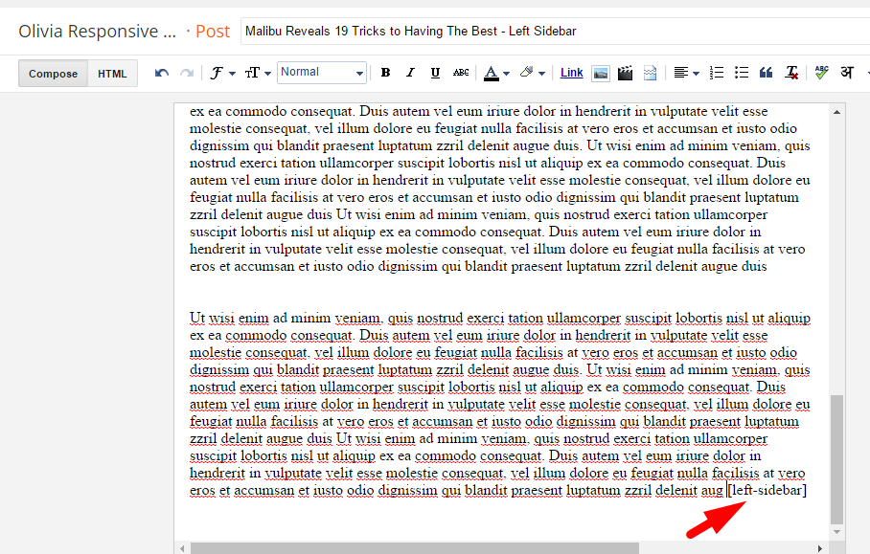**

### **11. Theme Customization**

Access your blog **Template >** click **Customize**.Here you can change the background, and apply pre-defined colors

Clicking Advanced You will see the official option to change the Main Color

